**4COSCO11C.2 Web Design and Development**

**Tutorial 2**

### Task 1 - Create your Web Page content

Create a file and save it on your home **h:** drive as **tutorial2.html**

**Important Notes:**

* No space in the filename.
* Remember to include the basic html tags: <head>, <body> etc.

Your Web Page should follow the following specifications.

#### **Part 1 - HTML**

* **Tutorial 2**for the title.
* **Tutorial 2 - Pool Schedule** as the <h1> heading
* **Your name** for the <h2> heading
* Create the Pool schedule shown in a HTML table. It is recommended that you spend some time working out the HTML required before typing it in.
* The first row of the table should contain the prices shown using a list. Hint: you need to span 6 columns in this first row.
  + You may need to use a HTML entity **&#163;** to display the '£' sign correctly. HTML character entities are used to display reserved characters.
* Demonstrate the use of both rowspan and colspan in the table.
* Remember, you can check if your markup is syntactically valid using the Validator at: <https://validator.w3.org/>  
  + Use the ‘Validate by File Upload’ or ‘Validate by Direct Input’.

**Fig 1:** Example of Schedule without CSS.

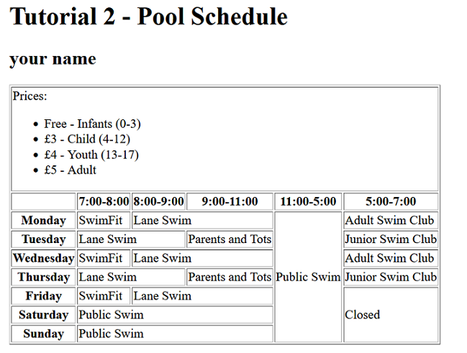

#### **Part 2 - CSS**

* Use CSS to style the Schedule. For example, give repeated items (such as SwimFit, Lane Swim) matching text or background colours.
  + Use an embedded or external style sheet and do NOT use inline styles.
  + Use a class to identify repeated items and apply a colour for each class.
* Experiment with padding to make space around the text within the <td>s.
* Use CSS to center the table using **margin-left: auto;** and **margin-right: auto;**.
* Center the <h1> and <h2> text using **text-align: center;**. Give the <h1> and <h2> a background color.
* Try using **tr:first-of-type { }** to add a style change to the **font-size**. Syles such as **first-of-type** and **first-child** are useful CSS pseudo-classes that can be used to access the first row of your table without having to create an id or class.
* Experiment with the border declarations **border-collapse: collapse;** and **border-collapse: separate;**.

**Fig 2:** Example of Schedule with CSS added. Be creative! Choose your own colour palette!

### 

* Additional CSS.
  + Experiment with the different border-style values: solid, dotted, dashed, double, groove, ridge, inset and outset.
  + Experiment with the unordered list styles: square, circle, disc (default), and none.

### Task 2 - Complete the Tutorial 2 Practice Test on Blackboard